PROJECT REPORT ON
IoT Based Class Monitoring Framework

submitted in partial fulfilment of the requirements for the award of degree of

BACHELOR OF ENGINEERING

In
COMPUTER SCIENCE AND ENGINEERING

Submitted by: Supervised By:
Jahanvi Sharma, 2210991692 Dr. Shyam Bhari Goyal
Rahul Mehra, 2210992130 Professor & Dean



DEPARTMENT OF COMPUTER SCIENCE AND ENGINEERING

CHITKARA UNIVERSITY

CHANDIGARH-PATIALA NATIONAL HIGHWAY, RAJPURA, PUNJAB, INDIA

Table of Contents

 | Page No.
Declaration | 3
Acknowledgement | 4
Abstract | 4
Introduction | 5
Objectives | 5
Dataset Description | 6
Methodology | 7
Results and Findings | 7
Tools and Technologies | 8
Actual Code Snippet and Result | 9-11
Prediction Outcome | 12
Conclusion & Future Scope | 12
References | 12
Appendices | 13

DECLARATION

I hereby certify that the work which is being presented in the project report entitled “IoT Based Smart Classroom Monitoring Framework” in partial fulfilment of requirement for the award of the degree of Bachelor of Engineering (Computer Science and Engineering) submitted in the department of Computer Science and Engineering at Chitkara University Institute of Engineering and Technology, Chitkara University, Punjab, India, is an authentic record of my own work carried out under the supervision of Dr. Shyam Goyal. The matter presented in this project report has not been submitted in any other university/institute for the award of any degree.

Place: Rajpura Jahanvi Sharma (2210991692)

Date : 29-04-2026 Rahul Mehra (2210992130)

This is to certify that the above statement made by the candidate is correct to the best of my knowledge and belief.

Dr. Shyam Bhari Goyal
Dean
Department of Computer Science and Engineering
Chitkara University Institute of Engineering and Technology, Chitkara University, Punjab, India

ACKNOWLEDGEMENT

We would like to express our deepest sense of gratitude and sincere thanks to our esteemed guide, Dr. Shyam Bhari Goyal, for his invaluable mentorship and constant encouragement. The profound insights, technical expertise, and meticulous feedback were instrumental in shaping the direction of this research work. We are truly fortunate to have had the opportunity to work under their supervision, which helped us navigate the complexities of this study with clarity and focus.
Our heartfelt thanks also go to the faculty members of the CSE Department for their continuous support and for sharing their knowledge, which significantly improved our methodological approach. Their constructive criticism and academic guidance provided us with a broader perspective on the subject matter.
We extend our gratitude to the administration of Chitkara University for providing the necessary infrastructure, advanced laboratory facilities, and a conducive research environment that were essential for the successful completion of this Research paper.
Finally, we would like to acknowledge the support of our peers and colleagues for their collaborative spirit and stimulating discussions. We are also grateful to everyone who, directly or indirectly, contributed their time and effort to help us bring this work to fruition.

Abstract
An IoT-based smart classroom monitoring system is designed to enhance the learning environment by integrating sensors, connectivity, and real-time data analytics to monitor and manage classroom conditions efficiently. The system utilizes various IoT devices such as temperature, humidity, light, noise, and occupancy sensors to continuously collect environmental and usage data. This data is transmitted to a central platform where it is analyzed and visualized for teachers and administrators, enabling informed decision-making. Features such as automated lighting and ventilation control, attendance tracking through RFID or facial recognition, and alerts for abnormal conditions help improve energy efficiency, student comfort, and security. By leveraging cloud computing and wireless communication technologies, the system ensures remote accessibility and scalability, ultimately contributing to a more intelligent, responsive, and resource-efficient classroom environment.

Introduction
The rapid advancement of the Internet of Things (IoT) has transformed traditional environments into smart and connected systems, enabling automation, efficiency, and real-time monitoring. In the field of education, classrooms are evolving from conventional setups to intelligent learning spaces that can adapt to students’ needs and improve overall teaching effectiveness. An IoT-based smart classroom monitoring system plays a crucial role in this transformation by integrating sensors, communication technologies, and data processing units to collect and analyze real-time information about classroom conditions.
This system focuses on monitoring key environmental parameters such as temperature, humidity, lighting, noise levels, and occupancy to ensure a comfortable and conducive learning atmosphere. Additionally, it can automate various classroom functions like lighting and ventilation, as well as support advanced features such as smart attendance systems using RFID or facial recognition technologies. By providing real-time insights and remote accessibility through cloud-based platforms, the system allows teachers and administrators to make informed decisions and maintain optimal classroom conditions. Overall, the implementation of IoT in classroom monitoring enhances efficiency, reduces energy consumption, and supports a smarter and more interactive educational environment.

Objectives
  - Monitor classroom environment (temperature, light, noise)
  - Automate lighting and energy usage.
  - Enable real-time monitoring.
  - Track attendance smartly.

Dataset Description
The dataset used in this project is sourced from Kaggle, which is containing survey responses related to Iot Based Smart Classroom Monitoring System.

Key Features Include:
  - Temprature Monitoring
  - Noise levels monitoring
  - Light Intensity
  - Attendance System

Data Preprocessing
To ensure data quality and model efficiency, the following preprocessing steps were performed:
  - Removal of irrelevant columns such as timestamp, comments, and state
  - Handling missing values:

    - Categorical data — filled using mode

    - Numerical data — filled using median

  - Encoding categorical variables using Label Encoding
  - Feature scaling using StandardScaler

Model Evaluation Metrics
The models were evaluated using:
  - Accuracy — Overall correctness of predictions
  - Precision — Correct positive predictions

Key Observations:
  - Real-time data improves classroom management.
  - Automation reduces energy consumption.
  - Smart attendance increases accuracy.

Tools and Technologies

- Programming Language: C++

- Dataset Format: CSV

- Version Control (optional): GitHub

Actual Code Snippet and Result
The following visual outputs were generated:
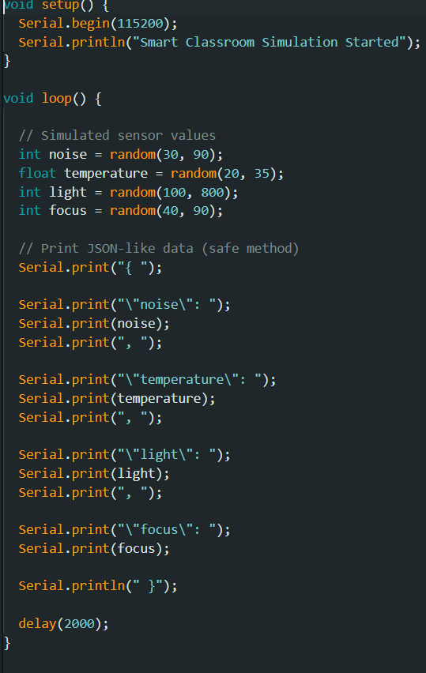
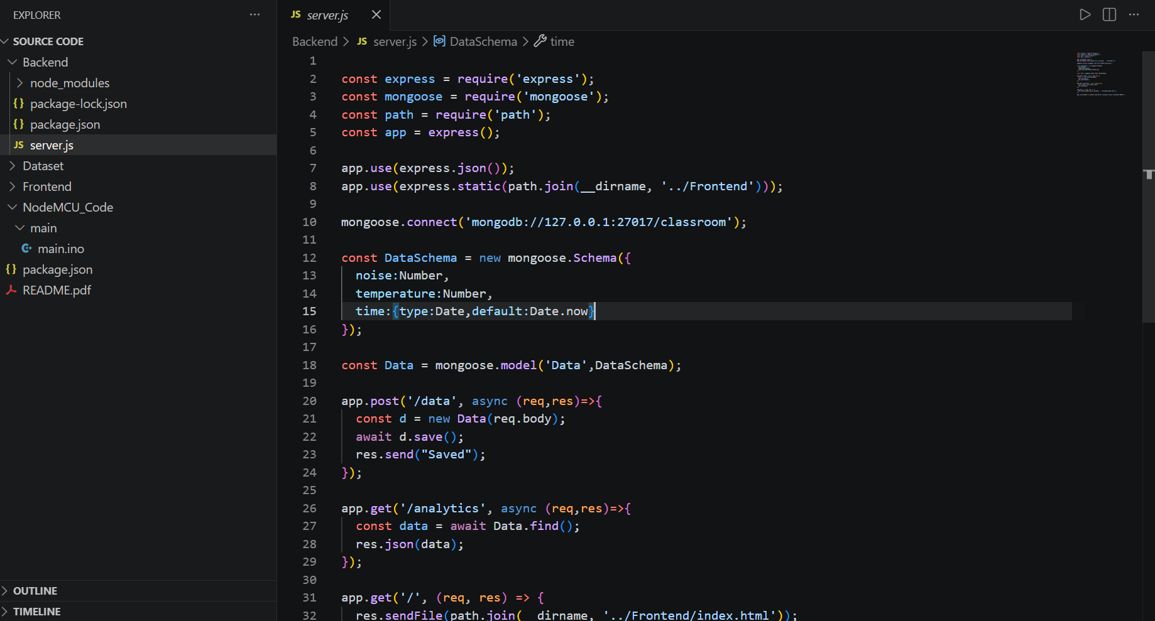

Prediction Outcome
The IoT-based smart classroom monitoring system is expected to create a more efficient, comfortable, and secure learning environment. It will likely reduce energy consumption through automation, improve attendance accuracy, and enable real-time decision-making. Additionally, the system can help maintain optimal classroom conditions, leading to better student focus and overall academic performance.

Conclusion
In conclusion, the IoT-based smart classroom monitoring system offers an effective solution for transforming traditional classrooms into intelligent learning environments. By integrating sensors, automation, and real-time data analysis, it enhances comfort, improves resource utilization, and strengthens safety measures. The system supports better decision-making for educators while promoting energy efficiency and accurate student management. Overall, it contributes to a more productive, responsive, and technologically advanced educational experience.

Future Scope
The future scope of an IoT-based smart classroom monitoring system includes the integration of artificial intelligence and machine learning to enable predictive analysis of student behavior and classroom conditions. Advanced features such as personalized learning environments, automated performance tracking, and adaptive resource management can further enhance educational outcomes. The system can also be expanded with facial recognition for enhanced security, integration with smart campus infrastructure, and improved cloud-based analytics for large-scale data management. Additionally, the use of mobile applications and edge computing can provide faster responses and greater accessibility, making the system more efficient and scalable.

References
- Dataset Source – Kaggle
- Scikit-learn Documentation
- Research articles on machine learning in mental health

